**Script Retrieval Documentation**

**Installing VS Code**

To run the script, we recommend using VS Code as the code editor as choice. Simply go to <https://code.visualstudio.com/> and install on machine.

**Installing Python**

The script is written in Python. To download, go to <https://www.python.org/downloads/> and select which version to download depending on if it is a Windows, Mac, or Linux computer.

**GitHub Steps**

To retrieve the source code from GitHub, you can do one of 2 steps.

1. In your terminal, place **git clone** [**https://github.com/tuckerdoyle123/csc400.git**](https://github.com/tuckerdoyle123/csc400.git)
2. Navigate to <https://github.com/tuckerdoyle123/csc400> and select download as Zip. Then, in VS Code, select File -> Open Folder; Open Folder after UnzippingA screenshot of a computer

   Description automatically generated

**Scopus API Key**

1. Go to <https://dev.elsevier.com/> to obtain an API Key. Create an account if you do not have one; otherwise sign in.

1. Select Create API Key, give it a name and click submit.A screenshot of a computer

   Description automatically generated

**Zotero API Key**

1. Access <https://www.zotero.org/> and create account/log in

1. After logging in, navigate to name and select My Profile

1. Select Settings, then navigate to Feeds/API

1. Select Create new private key

1. You will be prompted to give a key description and options for the API Key.
   * For personal library select all 3 options.
   * For default group permissions, select Read/Write.
   * Leave Specific Groups unchecked.
   * Once you save the key, it will display your API Key. **\*\*\*\*Make sure to save this API Key, as you will not be able to view it once you leave the page. \*\*\*\***

**Formspree Signup**

1. Go to <https://formspree.io/register> to sign up
2. Once signed up, next to My First Project click the + symbol and select New Form

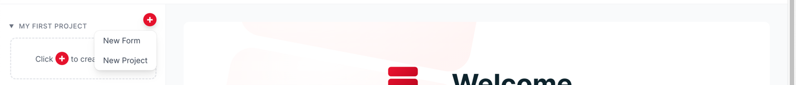

1. Create a form with the email address you wish to receive emails to. A new page will pop up with your forms endpoint. **Save this as it will be inserted into the application, app2.py, on line 36.**

**VS Code Flask and Library Installations**

To be able to run the script, the local machine must have specific libraries installed in VS Code within the virtual environment that will be created.

For the following commands, pip will be used. If pip does not run on your machine, run the following lines in your cmd terminal on Windows.

curl [https://bootstrap.pypa.io/get-pip.py -o get-pip.py](https://bootstrap.pypa.io/get-pip.py%20-o%20get-pip.py)

python get-pip.py

1. Open VS Code. Select File, Open Folder and select folder retrieved from Github
2. Select Terminal, then New Terminal
3. Once the terminal is open, run the following lines one at a time
   * pip install pybliometrics
   * pip install crossref-commons
   * pip install pyzotero
   * pip install pandas
4. To create a virtual environment, run: pip install virtualenv
5. Next, run: virtualenv env (only need to run this first time)
6. Next, to activate the environment depending on if it’s a Mac or Windows run
   * Mac: source env/bin/activate
   * Windows: \\env\Scripts\activate.bat
7. Once the environment is running, run the following lines one at a time to install the required libraries for the virtual environment
   * pip install flask
   * pip install pybliometrics
   * pip install crossref-commons
   * pip install pyzotero
   * pip install pandas
   * pip install requests
8. On lines 18-20 and 97 in **ScopusToZoteroScript.py**, update the following lines:
   * Line 18: add Name and Email
   * Line 20: add Name and Email
   * Line 99: Update first value 4421509, second value with group, and value with your API Key from Zotero
9. On lines 10-12 in **app2.py**:
   * Line 11: add Name and Email
   * Line 12: add Name and Email
   * Line 36: add the Formspree endpoint
10. On line 11 in **functions.py**, update the following line:
    * Update first value 4421509, second value with group, and value with your API Key from Zotero
11. To use Scopus API Key, follow these steps
12. If the configuration file doesn’t exist, pybliometrics prompts you to provide the values on first import. Run the **ScopusToZoteroScript.py** file by clicking dropdown next to the run button, which is the sideways triangle. Then hit Run Python File

1. First up is a prompt which is for your API key, input it hereA computer screen with white text

   Description automatically generated
2. Second is an InstToken which is not needed if running within the institution. Simply hit enter

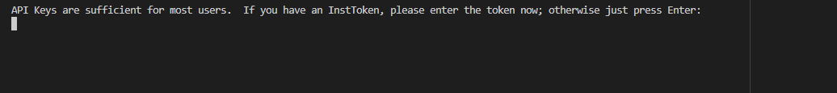

1. **ScopusToZoteroScript.py** can now be run after inputting the required keys. This is the script that will pull the Scopus and Crossref data. Hit the run button, or in the terminal run **python ScopusToZoteroScript.py**
2. To run the Form, within the virtual env, run the following in the terminal: **python app2.py**A screen shot of a black screen

   Description automatically generated
3. In the browser, type in: localhost:5000/user_input